Cloud Computing Project Report
WarrantyHub: Cloud-Based Warranty Management System
Project Name: WarrantyHub
Technology Stack: React (Vite), Spring Boot, MySQL (TiDB Cloud)

Vignesh (23WU0101189)
Leehan (23WU0101179)
Abhishek (23WU0101178)

1. Introduction
WarrantyHub is a comprehensive cloud-based warranty management system designed to revolutionise how users track, manage, and maintain their product warranties. In today's consumer-driven world, individuals and households accumulate numerous products with varying warranty periods, from electronic devices and home appliances to vehicles and furniture. Managing these warranties through traditional paper-based methods or scattered digital files has become increasingly challenging and inefficient.
The application provides a centralized platform where users can register their product warranties, upload supporting documentation, receive automated expiration notifications, and access their warranty information from anywhere with internet connectivity. By leveraging modern cloud computing technologies, WarrantyHub ensures that warranty information is securely stored, always accessible, and never lost.
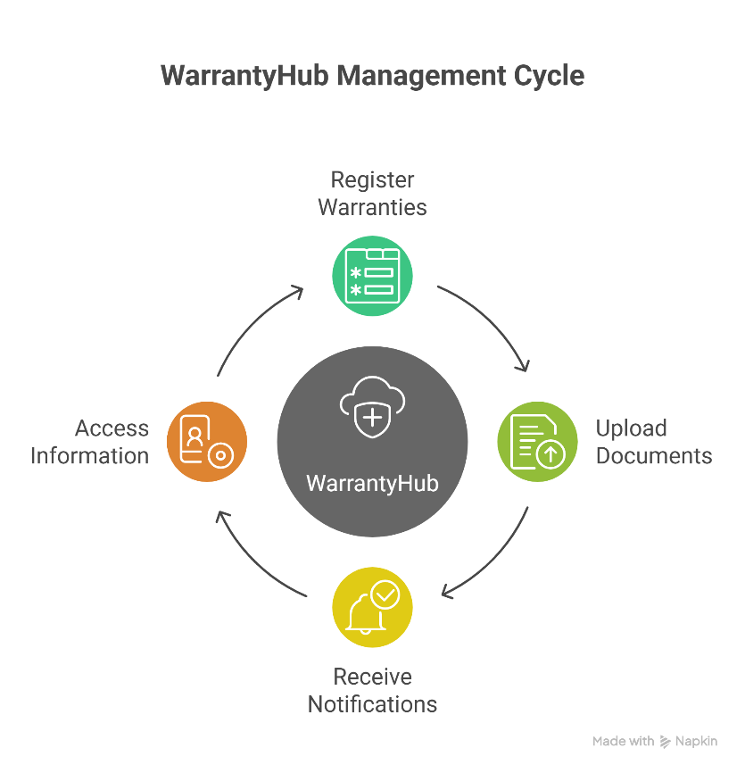
1.1 Key Features
WarrantyHub offers the following core functionalities that address the complete lifecycle of warranty management:
Warranty Registration and Management
Users can register product warranties with comprehensive details, including product name, brand, model number, serial number, purchase date, and warranty period. The system automatically calculates expiration dates and maintains warranty status (active, expired, or claimed).
Document Upload and Storage
The platform supports uploading and securely storing warranty-related documents such as purchase receipts, warranty cards, product manuals, and service records. Documents are associated with specific warranties for easy retrieval.
Automated Expiration Tracking
The system continuously monitors warranty expiration dates and sends proactive email notifications to users before their warranties expire, ensuring they never miss the opportunity to claim warranty services.
User Dashboard
A comprehensive dashboard provides users with an overview of all registered warranties, upcoming expirations, recently added items, and warranty statistics, enabling efficient warranty portfolio management.
Secure Authentication
Integration with Google OAuth 2.0 provides secure, password-less authentication, eliminating the need for users to create and remember additional credentials while ensuring robust security.
Email Notifications
Automated email service delivers welcome messages, warranty expiration reminders, and password reset functionality, keeping users informed about their warranty status.
1.3 Cloud Computing Integration
WarrantyHub extensively leverages cloud computing principles and services to deliver a scalable, reliable, and accessible solution:
- Cloud Database (TiDB Cloud): A distributed, MySQL-compatible database hosted on AWS infrastructure in the Singapore region, providing reliable data storage with built-in scalability and fault tolerance.
- Containerization (Docker): Both frontend and backend components are containerized, enabling consistent deployment across different environments, efficient resource utilisation, and horizontal scalability.
- Cloud Authentication (Google OAuth 2.0): Delegating authentication to Google's cloud infrastructure ensures enterprise-grade security without the complexity of managing user credentials.
- Cloud Email Service: Integration with SMTP-based email services enables automated notifications and communication with users.
- Distributed Architecture: The application follows a microservices-oriented approach with independent frontend, backend, and database layers that can be deployed, scaled, and updated independently.

2. Problem Statement
Modern consumers face several critical challenges in managing their product warranties effectively:
Physical Document Management
Traditional warranty management relies on physical documents such as purchase receipts, warranty cards, and product manuals. These papers are easily misplaced, damaged, or lost over time, making it impossible to claim warranty services when needed. Organizing and maintaining physical warranty documents across multiple products becomes increasingly difficult as the number of purchases grows.
Missed Expiration Dates
Without a systematic tracking mechanism, consumers often forget warranty expiration dates. This results in missing opportunities to claim warranty services for defective products, leading to unnecessary out-of-pocket expenses for repairs or replacements that should have been covered under warranty.
Information Fragmentation
Warranty information is scattered across various locations—physical documents stored in drawers, digital receipts in email inboxes, warranty cards in product packaging, and service records in different files. This fragmentation makes it time-consuming and frustrating to locate specific warranty information when needed.
Lack of Accessibility
Physical warranty documents are only accessible at home, creating problems when warranty information is needed while traveling, at a service center, or at a retail location. Similarly, warranty information stored on a single device is not accessible from other devices or locations.
No Proactive Reminders
Traditional warranty management provides no mechanism for proactive reminders. Users must manually track expiration dates and remember to check warranty status periodically, which is impractical given the number of products most households own.
Security and Backup Concerns
Physical documents can be destroyed in accidents, fires, or floods. Digital files stored locally are vulnerable to device failures, data corruption, or accidental deletion without proper backup mechanisms.
The Need for a Cloud-Based Solution
These challenges highlight the need for a modern, cloud-based solution that:
- Centralizes all warranty information in a secure, accessible location
- Automatically tracks expiration dates and sends proactive notifications
- Provides anytime, anywhere access from any internet-connected device
- Ensures data security and backup through cloud infrastructure
- Eliminates the burden of managing physical documentation
- Simplifies warranty information retrieval during claims or service requests
WarrantyHub addresses these challenges by providing a comprehensive cloud-based warranty management platform that transforms how consumers track and manage their product warranties.

3. Objectives Completed
3.1 Core Functional Objectives
✓ Document Upload and Management
Developed a robust document upload system supporting multiple file formats (PDF, JPEG, PNG) with file size validation. Documents are securely stored and associated with specific warranties, enabling users to maintain complete warranty documentation digitally.
✓ User Authentication and Authorization
Integrated Google OAuth 2.0 for secure, password-less authentication. Users can sign in using their existing Google accounts, eliminating the need to create and manage additional credentials. JWT token-based session management ensures secure API access.
✓ Automated Email Notifications
Implemented a scheduled email notification system that automatically checks for warranties nearing expiration and sends reminder emails to users. The system sends welcome emails upon registration and supports password reset functionality.
3.2 Cloud Computing Implementation Objectives
✓ Cloud Database Deployment
Successfully deployed and integrated TiDB Cloud as the primary database solution. The MySQL-compatible distributed database is hosted on AWS infrastructure in the Singapore region (ap-southeast-1), providing reliable, scalable data storage.
✓ RESTful API Architecture
Developed a comprehensive RESTful API backend using Spring Boot, exposing well-defined endpoints for warranty management, user operations, document handling, and dashboard data retrieval. The API follows REST conventions with appropriate HTTP methods and status codes.
✓ Container-Based Deployment
Containerized both frontend (React) and backend (Spring Boot) applications using Docker. Multi-stage Docker builds optimize image sizes, and containers are configured with environment-based settings for deployment flexibility.
✓ Cross-Origin Communication
Configured and implemented CORS (Cross-Origin Resource Sharing) policies enabling secure communication between the frontend and backend, which may be hosted on different domains or ports.
3.3 Technical Architecture Objectives
✓ Three-Tier Architecture
Successfully implemented a complete three-tier architecture separating presentation (React frontend), application logic (Spring Boot backend), and data storage (TiDB Cloud) layers. This separation ensures maintainability, scalability, and independent component updates.
✓ External Service Integration
Integrated multiple external cloud services including Google OAuth 2.0 for authentication and SMTP services for email delivery, demonstrating the ability to work with cloud-based APIs and services.
✓ Distributed System Design
Designed and implemented a distributed system architecture where frontend, backend, and database components operate as independent services communicating through well-defined interfaces (REST APIs, MySQL protocol).
✓ Scalability Foundation
Established architectural foundations for horizontal scalability through stateless backend design, containerization, and connection pooling, enabling future scaling to handle increased user load.

4. Cloud Features
4.1 Cloud Database (TiDB Cloud)
Distributed SQL Database Architecture
TiDB Cloud provides a distributed, MySQL-compatible database solution that combines the best of traditional SQL databases with cloud-native distributed architecture. The database consists of multiple layers:
- TiDB Server Layer: Stateless SQL processing layer that accepts client connections, parses queries, and generates execution plans
- TiKV Storage Layer: Distributed transactional key-value storage providing data persistence with automatic sharding and replication
- PD (Placement Driver): Cluster management and metadata coordination
Key Cloud Database Features:
Managed Service Benefits
TiDB Cloud operates as a fully managed database service, eliminating the operational overhead of database administration. The platform automatically handles database setup, configuration, patching, backups, and monitoring. This allows developers to focus on application logic rather than infrastructure management.
High Availability and Fault Tolerance
The distributed architecture provides built-in redundancy through data replication across multiple nodes. In production tiers, automatic failover ensures continuous availability even if individual nodes fail. The Raft consensus algorithm guarantees data consistency across replicas.
Horizontal Scalability
TiDB's distributed architecture enables horizontal scaling by adding more nodes to the cluster. Data is automatically sharded (partitioned) and distributed across nodes as the dataset grows, ensuring consistent performance regardless of data volume.
Geographic Deployment
The database is deployed in AWS ap-southeast-1 (Singapore) region, providing optimal latency for users in Southeast Asia, India, and Australia. The cloud provider's global infrastructure ensures reliable connectivity and performance.
Security Features
All database connections use TLS/SSL encryption to protect data in transit. Access is controlled through authentication credentials, and the cloud provider manages security patches and updates automatically.
Integration with WarrantyHub:
The Spring Boot backend connects to TiDB Cloud using standard MySQL JDBC drivers. Connection pooling through HikariCP ensures efficient resource utilization. Spring Data JPA provides object-relational mapping, automatically converting Java objects to database records and vice versa.
4.2 Cloud Authentication (Google OAuth 2.0)
OAuth 2.0 Protocol
OAuth 2.0 is an industry-standard authorization framework enabling secure, delegated access. Instead of storing user passwords, WarrantyHub delegates authentication to Google's robust identity platform.
4.3 Containerization with Docker
Container Technology
Docker containers package applications with all dependencies, libraries, and configuration files into isolated, portable units. Containers share the host operating system kernel while maintaining application isolation, making them more efficient than traditional virtual machines.
Multi-Stage Docker Builds:
Frontend Container
The React frontend uses a multi-stage build process. The first stage uses a Node.js image to install dependencies and build the production-optimized bundle using Vite. The second stage uses a lightweight web server (Nginx or Node.js) to serve the static files, resulting in a much smaller final image.
Backend Container
The Spring Boot backend container packages the compiled JAR file with a Java runtime environment (OpenJDK). Environment variables configure database connections, authentication settings, and external service credentials without hardcoding sensitive information.

5. Architecture
5.1 System Architecture Overview
WarrantyHub implements a modern three-tier architecture that separates presentation, business logic, and data management concerns. This architectural pattern provides clear boundaries between components, enabling independent development, testing, and deployment.
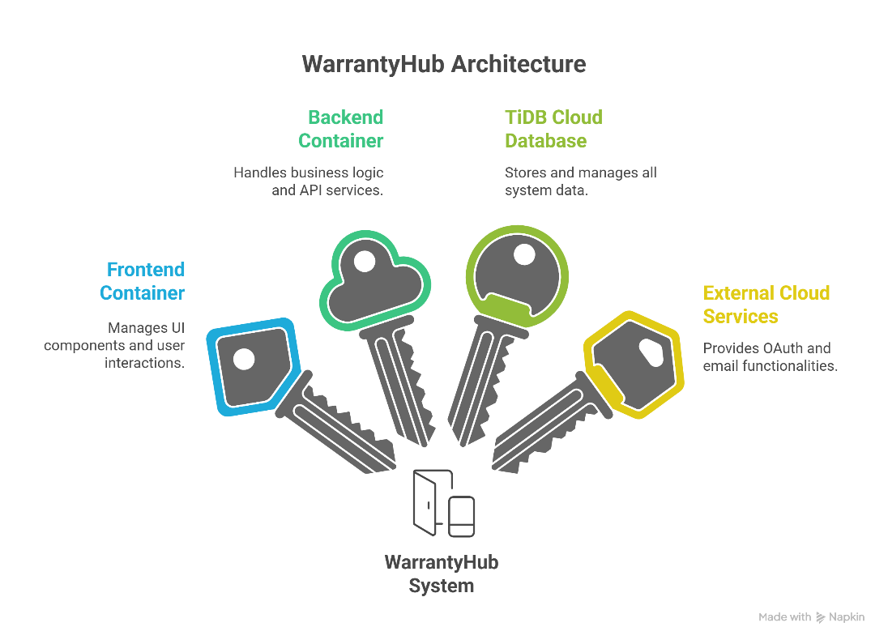
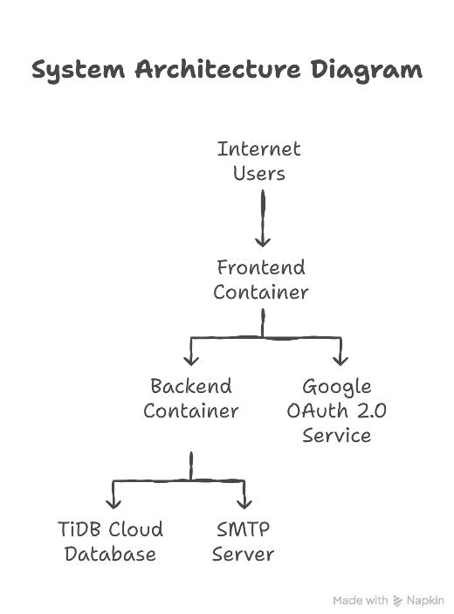

6. Results
6.1 Application Screenshots
Screenshot 1: User Authentication
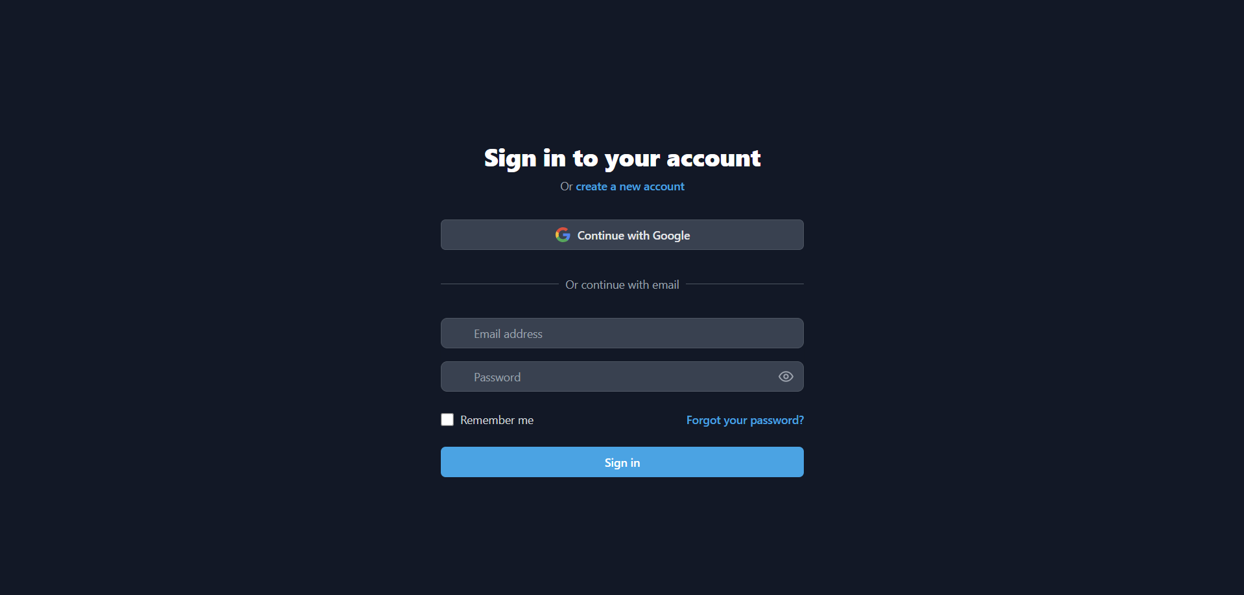
Screenshot 2: Dashboard Overview
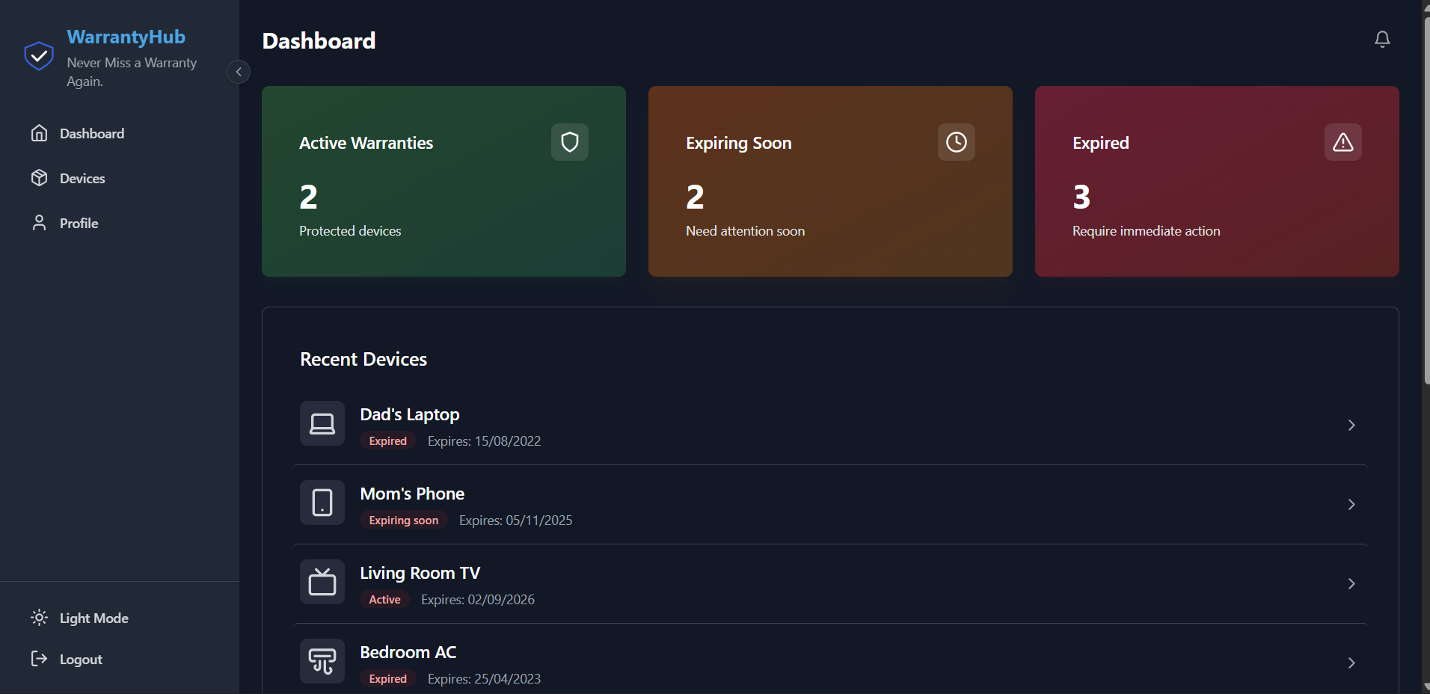
Screenshot 3: Warranty Registration
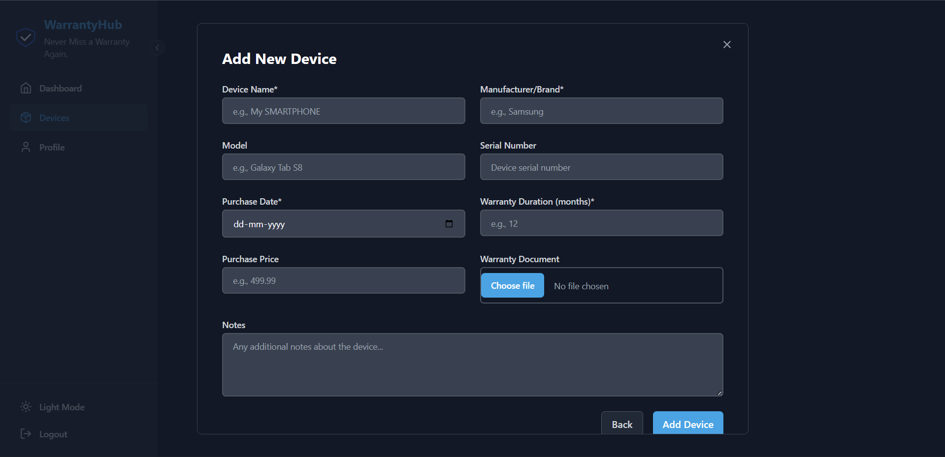
Screenshot 4: Warranty List
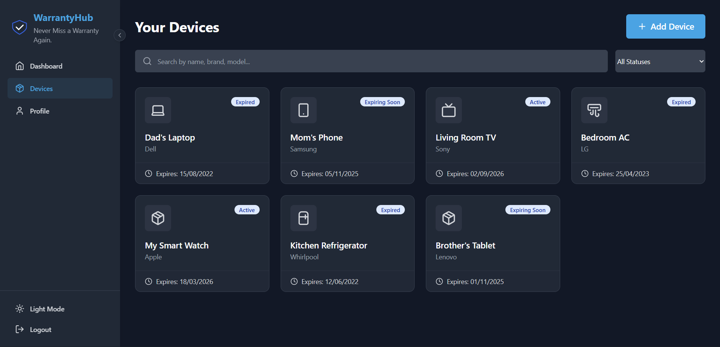
Screenshot 5: Warranty Details
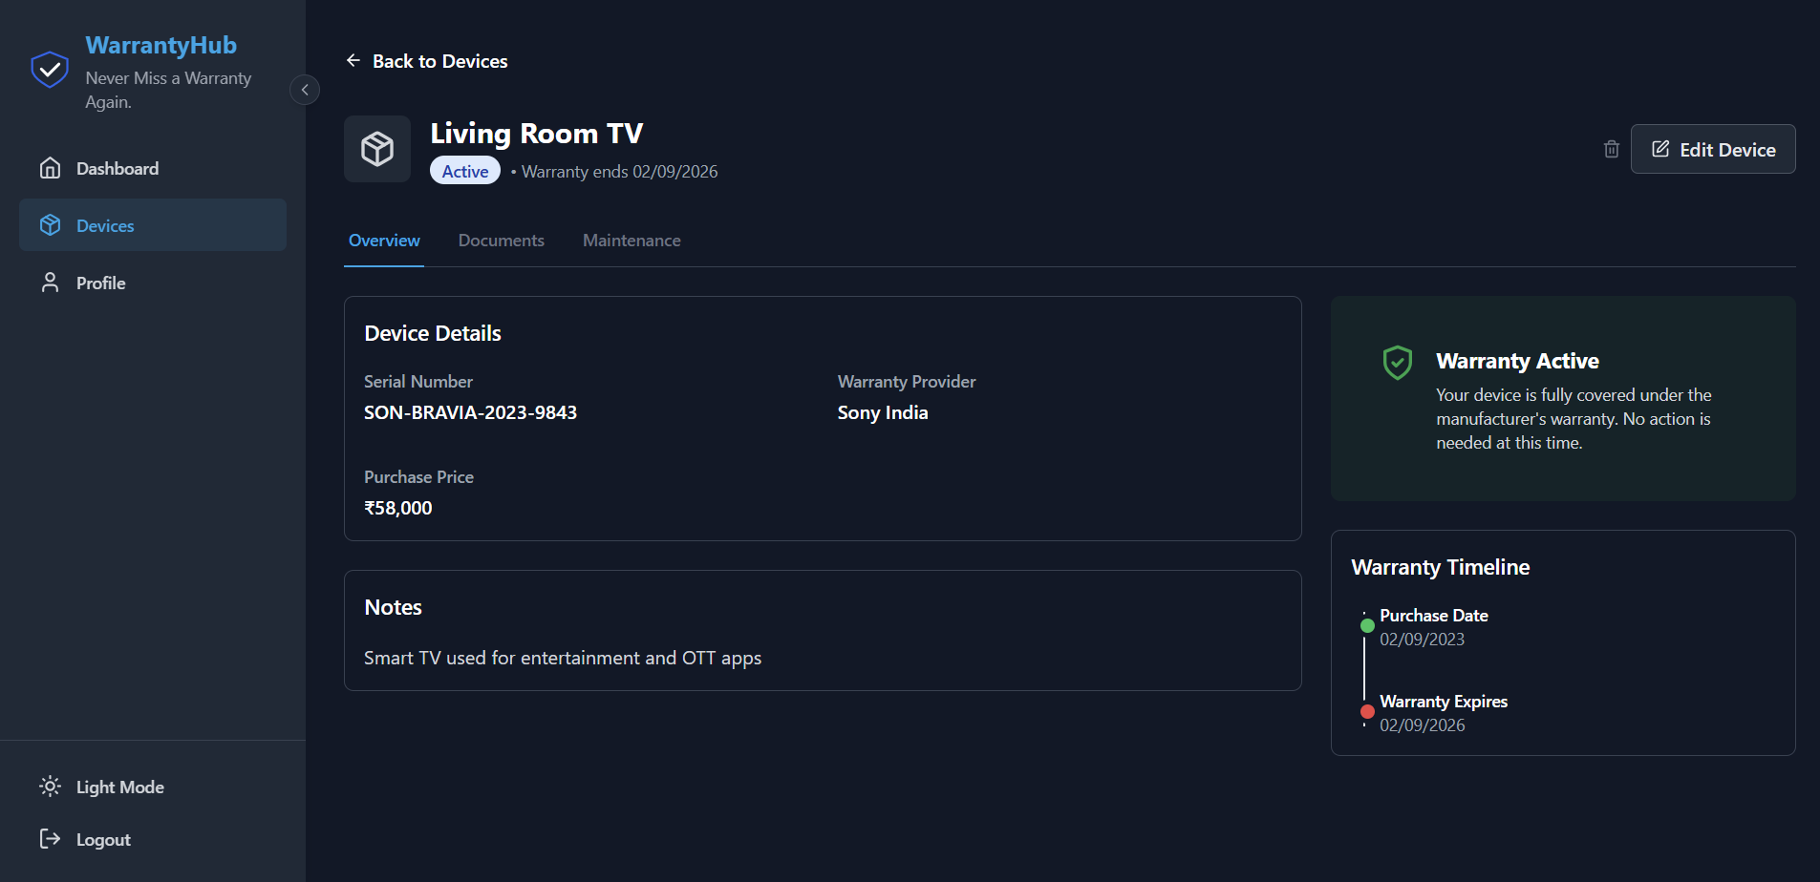
Screenshot 6: Document Upload
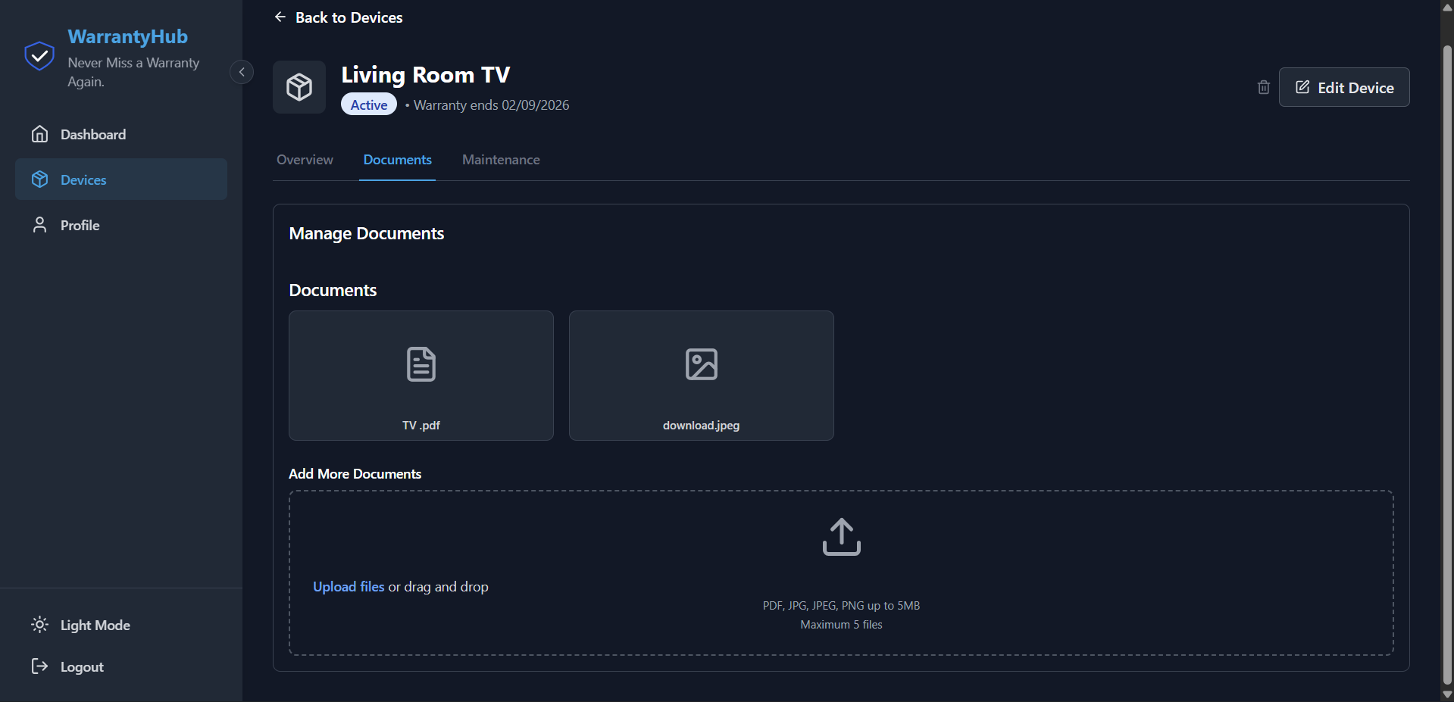
Screenshot 7: Email Notifications
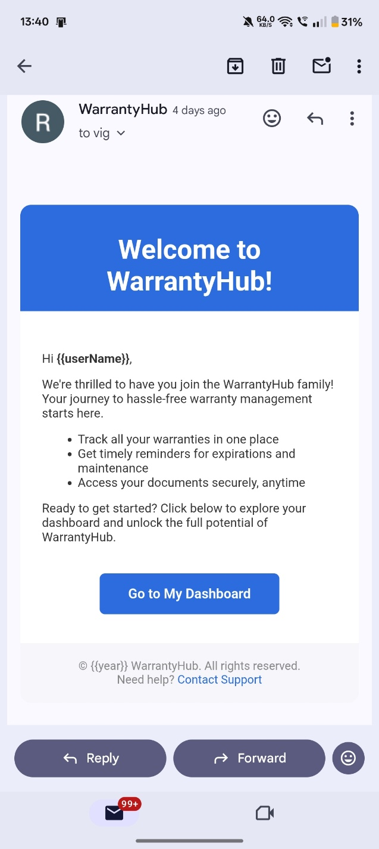

7. Conclusion
WarrantyHub successfully demonstrates the practical application of cloud computing principles in building a modern, scalable, and secure web application. The project achieves its primary objective of simplifying warranty management through an intuitive interface backed by robust cloud infrastructure.
The application addresses real-world challenges faced by consumers in managing product warranties. By providing centralized document storage, automated expiration tracking, and accessible warranty information, WarrantyHub transforms a traditionally manual and error-prone process into an efficient, automated solution.
Cloud Computing Implementation
The project effectively leverages multiple cloud computing technologies and concepts:
Cloud Database: TiDB Cloud provides a managed, distributed database solution demonstrating Infrastructure-as-a-Service (IaaS) and Platform-as-a-Service (PaaS) concepts. The MySQL-compatible interface simplifies integration while the distributed architecture provides scalability and reliability.
Cloud Authentication: Google OAuth 2.0 integration showcases Software-as-a-Service (SaaS) consumption, delegating authentication to a specialized cloud provider while maintaining application security.
Containerization: Docker containers demonstrate modern cloud-native development practices, enabling portability, consistency, and efficient resource utilization across development and production environments.
Distributed Architecture: The three-tier architecture with independent frontend, backend, and database layers illustrates microservices principles, enabling independent scaling and deployment of components.
7.3 Technical Achievements
Full-Stack Development: The project successfully integrates modern frontend technologies (React, Vite), robust backend frameworks (Spring Boot), and cloud database solutions (TiDB Cloud) into a cohesive application.
Security Implementation: Multi-layer security through OAuth 2.0, JWT tokens, HTTPS encryption, and secure database connections ensures user data protection and system integrity.
Automated Workflows: Scheduled email notifications demonstrate automated business processes, adding significant value by proactively alerting users before warranties expire.
RESTful API Design: Well-structured API endpoints following REST conventions enable clean separation between frontend and backend, facilitating future enhancements such as mobile applications.
By combining React for responsive user interfaces, Spring Boot for robust backend services, TiDB Cloud for distributed data management, and Docker for containerized deployment, WarrantyHub exemplifies best practices in cloud application development. The successful integration of external cloud services—Google OAuth 2.0 for authentication and SMTP for email delivery—demonstrates the ability to build complex systems by composing multiple cloud services.
As cloud computing continues to evolve and shape the future of software development, projects like WarrantyHub illustrate the practical possibilities and benefits of cloud-native architectures. The skills, knowledge, and architectural patterns employed provide a strong foundation for building enterprise-scale, production-ready applications in cloud environments.

